**Introduction**

Diabetes is a lifelong disease that is a gateway to other medical issues that may contribute in the future to other health complications. The number of people living with diabetes is estimated at around 366 million world-wide, and 553 million by 2030. As a consequence, protocols are currently prescribed in the hospital[6, 7].

A new clinical research review was carried out to analyze past trends in diabetes diagnosis by patients with diabetes in a hospital and to guide future guidance leading to patient health changes. We observed in particular the use of HbA1c in a wide number of people with a diagnosis of diabetes mellitus as a indication of commitment to diabetes treatment.

**2. Data**

There were five properties and 101,731 observations in the original dataset. The data were subjected to intensive cleaning procedures to optimize the data collection for modeling. 91 841

***Table 1: list of Variables in the original data set and their characteristics***

|  |  |  |
| --- | --- | --- |
| **Variable Name** | **Measurement Level** | **Range of Values** |
| weight_new | Interval | 165, 175… |
| Weight | Nominal | [150-170]…[170-200] |
| time_in_hospital | Interval | 1 to 14 |
| Readmitted | Nominal | No, <30, >30 |
| Re_admitted | Binary | 0 to 1 |
| Race | Nominal | Asian, Caucasian… |
| patient_nbr | Interval | ID |
| number_outpatient | Interval | 0 to 42 |
| number_inpatient | Interval | 0 to 21 |
| number_emergency | Interval | 0 to 76 |
| number_diagnoses | Interval | 1 to 16 |
| num_procedures | Interval | 0 to 6 |
| num_medications | Interval | 1 to 81 |
| num_lab_ procedures | Interval | 1 to 132 |
| medical_specialty | Nominal | 1 to 23 |
| gender | Char | Male, Female, Other |
| encounter_id | Interval | 12522 to 443867222 |
| discharge_disposition_id_2 | Nominal | 1 to 17 |
| discharge_disposition_id | Nominal | 1 to 28 |
| Diagnosis_3 | Nominal | 3 to 999 |
| Diagnosis_2 | Nominal | 5 to 999 |
| Diagnosis_1 | Nominal | 3 to 999 |
| diabetesmed2 | Binary | 0 to 1 |
| change2 | Binary | 0 to 1 |
| age | Nominal | [0-10]... [90-100] |
| admitted_30days | Binary | 0 to 1 |
| admission_type_id2 | Nominal | 1 to 4 |
| Admission_source_id | Nominal | 1 to 25 |
| A1Cresult | Nominal | 7, >8, none, norm |
| 24 features for medications | Nominal/Binary | Metformin, Glipizide…… etc. |

**Data preprocessing.**

.

There were insufficient values for nominal values such as sex, race, emergency service and discharge. Upon being implemented in the process, these lacking values have to be addressed because they can generate uncertainty and bias in our GLM process. The observations that the missing values have been excluded from analyzes by removing NA to eliminate the imputation of missing values in principal, secondary and tertiary diagnoses. The term 'Medical Specialty,' with nearly 50 percent lost values, refers to the medical specialty of the practitioner who treated and identified the condition originally. The 97 percent lost value of the vector 'Weight.' Weight, payer code and medical variables were dismissed in the model building after due thought. Data for meetings that followed the following requirements was removed from the document.

(1) This is an inpatient consultation (admission to a hospital).

(2) The "diabetic" experience means that any form of diabetes has been diagnosed in the system.

(3) The stay was not exceeding 1 day and not exceeding 14 days.

(4) During the incident, laboratory work was carried out.

(5) During the experience medications were administered.

Other factors, such as weight, race, and experience Identification, featured anomalies such as markers for questions and other unique characters. Invalid gender identity findings have been excluded. For outliers, data were tested through boxes and whiskers. Outside the ±3 standard deviation margin, the results were deemed outliers and were therefore deleted with R code. The readmission objective variable had three stages of '30' and 'no' (patient was remitted within 30 days). Remember that 30 days have been allocated according to the parameters commonly used by funders. Hemoglobin A1C (HbA1c) is a significant indicator of the regulation of glucose that is generally used to assess diabetes performances [10, 11]. The evaluation of HbA1c provides unique potential during hospital entry to evaluate and improve clinical care efficacy as needed (e.g. HbA1c > 8.0% on continuing treatment).

Within three months of sentinel entry, a test response HbA1c was believed to not duplicate the test from an outpatient or inpatient examination.

This report re-codes the aim variable as '1' (re-admitted patient), and '0' (no re-admitted patient) as binary variable. Gender, age , race, source of entry, nature of condition, medical specialty primary diagnostics and spending time on hospital are the variables that were selected for monitoring of the patient's demographic and disease severity.

**Model Building**

The research process is a session; nevertheless, we have examined one experience only per individual to keep the results separate. After the preliminary analysis, the p value was calculated with less than 0.01 and the amount of proof was taken into account. In monitoring of covariates including age, disease severity, type and intake scale, multi variable logistic regression has been used to adjust the relation between early re-entry and HbA1c calculations. In four stages we developed our model to decide if the candidate covariates were substantially related with readmission. For each step, the significance test for the higher degree of freedom variables was carried out, a deviance table analysis and a sensitivity analysis was performed, this was achieved when one variable was omitted and beta-coefficient improvements were tested.

First, we have built a logistic model that includes all the variables except HbA1c. Furthermore, to the main concept we added HbA1c. Thirdly, the core model (without HbA1c) was coupled with interactions and only the relevant interactions remained there. We have also attached pairs to HbA1c, leaving in the final model only the relevant interactions. Examples have been used in the final model to describe interaction terminology.

**Results**

The HbA1c test was uncommon, arising in just 18.4% of cases in which diabetes mellitus was used as a condition of entry. 51.4% were fewer than 8 percent of those who requested the study. In cases in which a HbA1c had not been collected, 42.5 percent of the patients got prescription modifications during hospitalization; while the physicians who requested the check tended to have replied a little bit more as calculated by medication improvements (55,0 per cent, P < 0,001). As for readmission, the HbA1c testing was correlated with a significantly lower readmission rate (9.4 versus 8.7%, P = 0.007) as a whole without correction for the covariate. This was valid regardless of the test findings.

***Table 2: Values of the primary diagnosis in the final dataset. In the analysis, groups that covered less than 3.5% of encounters were grouped***

|  |  |  |  |  |
| --- | --- | --- | --- | --- |
| Group name | icd9 codes | Number of  encounters | % of  encounter | Description |
| Others | 740–759 | 41 | 0.1% | Congenital anomalies |
|  | 360–389 | 216 | 0.3% | Diseases of the sense organs |
|  | 630–679 | 586 | 0.8% | Pregnancy, birth and puerperium risks. |
|  | 280–289 | 652 | 0.9% | Blood disease and organ formation. Blood diseases |
|  | 320–359 | 634 | 0.9% | Diseases of the nervous system |
|  | E–V | 918 | 1.3% | External damage conditions and extra ranking |
|  | 290–319 | 1,544 | 2.2% | Mental disorders |
|  | 001–139 | 1,683 | 2.4% | Parasite and infectious diseases |
|  | 240–279, without 250 | 1,851 | 2.6% | Endocrine, dietary, metabolic and immune disorders |
|  | 680–709, 782 | 1,846 | 2.6% | Body and subcutaneous tissue disorders |
|  | 780, 781, 784, 790–799 | 2,136 | 3.1% | Other symptoms, signs, and ill-defined conditions |
| Neoplasms | 140–239 | 2,536 | 3.6% | Neoplasms |
| Genitourinary | 580–629, 788 | 3,435 | 4.9% | Genitourinary organ states |
| Musculoskeletal | 710–739 | 4,076 | 5.8% | Musculoskeletal and connective tissue disorders |
| Injury | 800–999 | 4,697 | 6.7% | Injury and poisoning |
| Diabetes | 250.xx | 5,747 | 8.2% | Diabetes mellitus |
| Digestive | 520–579, 787 | 6,485 | 9.3% | Diseases of the digestive system |
| Respiratory | 460–519, 786 | 9,490 | 13.6% | Respiratory system diseases |
| Circulatory | 390–459, 785 | 21,411 | 30.6% | Circulatory control diseases |

We investigated the relationship between HbA1c readmission and adjustment to covariates such as age, patient form and extent and disease. As the gender variable was not important (P = 0.36), additional analyzes were not included in the core model (without HbA1c). The values of beta-coefficients in the model have been changed by approximately 35% by dose monitoring, excluding the hospital duration, medical condition, age and primary diseases that have increased by 77%, by 47%, by 49% and by 65% by the duration the release was omitted. It includes the interaction between these factors. The related pairs were included in their covariance associations: discharge with ethnicity (P < 0.001), referral specificity (P = 0.001), primary diagnosis (P = 0.005), period with an institution (P > 0.001), hospital admissions (P = 0.001); admission procedure (P = 0.001) and age (P < 0.001), key period medical surgical conditions (P < 0.001) and HbA1c (P = 0.004). Only such interactions were used in the final model. The final analysis indicates that the main dependence on the relationship between readmission and HbA1c calculation is strongly contingent (note that diabetes is also a secondary diagnosis). In fact, the readmittance profile of patients with diabetes mellitus following covariate correction is significantly different from those with key diagnosis of circulatory disorders (P < 0.001), and interventions that suggest primary diagnosis of respiratory diseases (P = 0.02) applies to 52.4 percent of the planned (covariate-adjusted) encounter readmission for the three scenarios. Illustration 1. While, thresholds were determined and other covariate concentrations were estimated. There were no significant ties with other main diagnoses.

***Fig 1: R output of number of inpatient percentage***

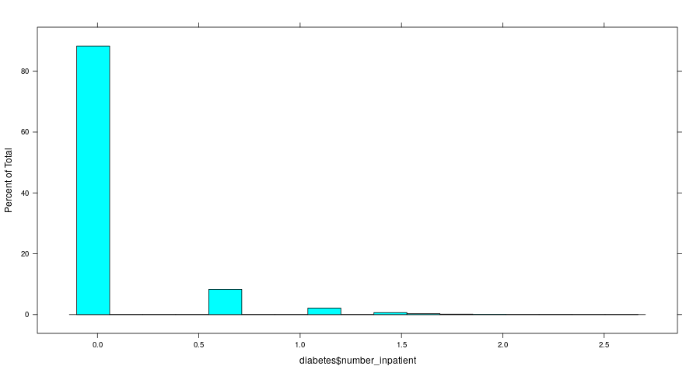

**Fig 2: R output of number of outpatient percentage**

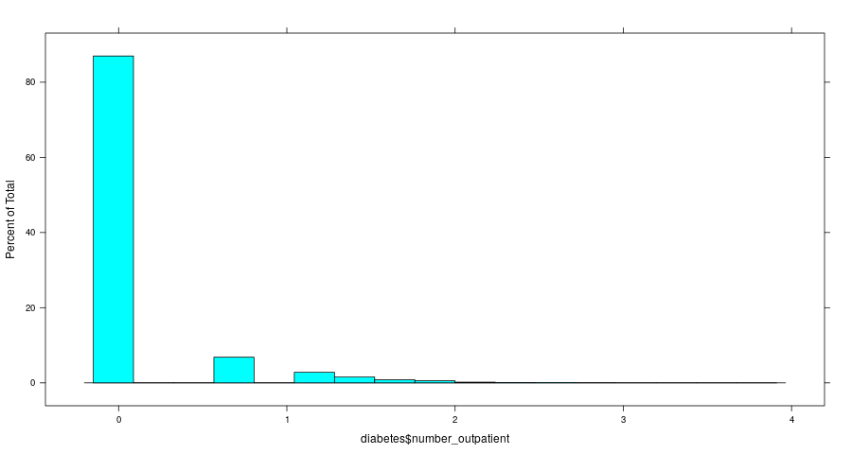

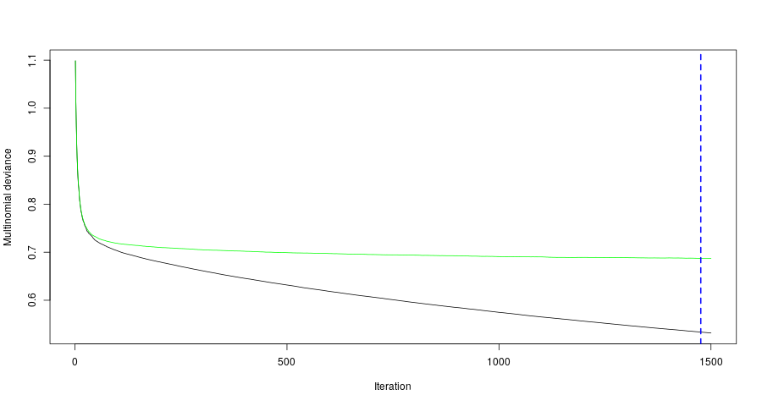

Our analysis was based on strongly restrictive criteria. Despite the lack of diabetes mellitus despite hospital discharges, that is definitely an underestimation, though [12] First and foremost, statistics show that even though diabetes testing has been used (0.1 per cent of the total), despite the general awareness of the utility of HbA1c as a success indicator [14, 15], the procedure is not commonly requested (18.4 per cent) in the hospital setting. Practitioners and affected care behaviors may not have had HbA1c values in our dataset. This may not be the result, though, of a dual diagraming method in which a diagnosis was recorded in the electronic health record. We accept this as a potential drawback of our data analysis. However, similar analyzes have reported a low HbA1c rate by other men. Just recently were the proposed levels of treatment that allow medication to stop on admission and may lead to improvements in glucose-based medicines adopted.

**Discussion**

In the absence of HbA1c fewer than half (42.5%) patients reported medicinal improvement during hospitalization, while those who demanded the check tended to be marginally more receptive to the results dependent on medicinal changes (55.0%, P < 0.001). Sadly, we cannot agree whether manufacturers have triggered the medical modifications in the patients in whom HbA1c has not been reported but persistently elevated glucose reading.

**Fig 4: Model Summary**

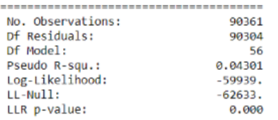

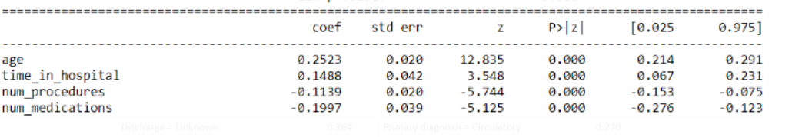

Regarding readmittances, our findings suggest that, while primary diagnosis of diabetes mellitus are not the prime diagnostic of circulatory or respiratory problems, only the assessment of HbA1c is correlated with a low readmission risk. The results also indicate the significant effect on readmission for these high-risk people of better exposure to diabetes in the hospital. The analysis cannot address cause and effect, however the improvements of the protocol should closely examine this principle. Hospitalization programs are barely able to affect change of patients ' health treatment habits. The available resources in the hospital environment are often much greater than those available to outpatient practitioners and can be utilized to influence care. The inpatient stays in the current dataset were, on average, 4.27 days that would require diabetes therapies to be checked and a strategy for improvement established should it be needed. The readmission details given underline the significance of this. They agree that the findings of the current study reflect a tentative inference with drawbacks inherent in these broad health records. The research is constrained by a nonrandomized sample plan as well as the limitations of dealing with broad clinical samples that were addressed previously. Our evidence, however, tends to support the argument that greater attention should be paid to glucose homeostasis in the hospital.

**References**

1. R. V. Shah, R. K. Altman, M. Y. Park et al., “Usefulness of hemoglobin A(1c) to predict outcome after cardiac resynchronization therapy in patients with diabetes mellitus and heart failure,” The American Journal of Cardiology, vol. 110, no. 5, pp. 683–688, 2012.
2. [M. E. Halkos, J. D. Puskas, O. M. Lattouf et al., “Elevated preoperative hemoglobin A1c level is predictive of adverse events after coronary artery bypass surgery,” Journal of Thoracic and Cardiovascular Surgery, vol. 136, no. 3, pp. 631–640, 2008.
3. K. A. Britton, V. Aggarwal, A. Y. Chen et al., “No association between hemoglobin A1c and in-hospital mortality in patients with diabetes and acute myocardial infarction,” The American Heart Journal, vol. 161, no. 4, pp. 657.e1–663.e1, 2011.
4. E. S.Moghissi,M. T.Korytkowski,M.DiNardo et al., “American association of clinical endocrinologists and American diabetes association consensus statement on inpatient glycemic control,”Diabetes Care, vol. 32, no. 6, pp. 1119–1131, 2009.
5. J. M. Stolker, J. A. Spertus, D. K. McGuire et al., “Relationship between glycosylated hemoglobin assessment and glucose therapy intensification in patients with diabetes hospitalized for acute myocardial infarction,” Diabetes Care, vol. 35, no. 5, pp. 991–993, 2012
6. Robbins JM, Valdmanis VG, Webb DA. Do public health clinics reduce rehospitalizations?: the urban diabetes study. J Health Care Poor Underserved. 2008;19:562–573 [PubMed] [Google Scholar]
7. Kim H, Ross JS, Melkus GD, Zhao Z, Boockvar K. Scheduled and unscheduled hospital readmissions among patients with diabetes. Am J Manag Care. 2010;16:760–767
8. Bennett KJ, Probst JC, Vyavaharkar M, Glover SH. Lower rehospitalization rates among rural Medicare beneficiaries with diabetes. J Rural Health. 2012;28:227–234
9. American Diabetes Association. Fast Facts: Data and Statistics about Diabetes. http://professional.diabetes.org/admin/UserFiles/0%20-%20Sean/Documents/Fast_Facts_9-2014.pdf Accessed October27, 2014
10. Young BA, Lin E, Von Korff M, et al. . Diabetes complications severity index and risk of mortality, hospitalization, and healthcare utilization. Am J Manag Care. 2008;14:15–23
11. Chang HY, Weiner JP, Richards TM, Bleich SN, Segal JB. Validating the adapted Diabetes Complications Severity Index in claims data. Am J Manag Care. 2012;18:721–726 16. Piette JD, Kerr EA. The impact of comorbid chronic conditions on diabetes care. Diabetes Care. 2006;29:725–731
12. Ginde AA, Blanc PG, Lieberman RM, Camargo CA., Jr. Validation of ICD-9-CM coding algorithm for improved identification of hypoglycemia visits. BMC Endocr Disord. 2008;8:4.
13. Sue Kirkman M, Briscoe VJ, Clark N, et al. . Diabetes in older adults: a consensus report. J Am Geriatr Soc. 2012;60:2342–2356
14. Agency for Healthcare Research and Quality Center for Financing, Access, and Cost Trends. MEPS HC-129 2009 Full Year Consolidated Data File, November 2011. http://meps.ahrq.gov/mepsweb/data_stats/download_data/pufs/h129/h129doc.pdf Accessed May14, 2014
15. Mehta S, Chen H, Johnson ML, Aparasu RR. Risk of falls and fractures in older adults using antipsychotic agents: a propensity-matched retrospective cohort study. Drugs Aging.
16. Tinetti ME, Gordon C, Sogolow E, Lapin P, Bradley EH. Fall-risk evaluation and management: challenges in adopting geriatric care practices. Gerontologist. 2006;46:717–725
17. Goldberg JF, Brooks JO 3rd, Kurita K, et al. . Depressive illness burden associated with complex polypharmacy in patients with bipolar disorder: findings from the STEP-BD. J Clin Psychiatry. 2009;70:155–162
18. Anger JT, Saigal CS, Madison R, Joyce G, Litwin MS; Urologic Diseases of America Project. Increasing costs of urinary incontinence among female Medicare beneficiaries. J Urol. 2006;176:247–251
19. Lemieux J, Sennett C, Wang R, Mulligan T, Bumbaugh J. Hospital readmission rates in Medicare Advantage plans. Am J Manag Care. 2012;18:96–104
20. Jack BW, Chetty VK, Anthony D, et al. . A reengineered hospital discharge program to decrease rehospitalization: a randomized trial. Ann Intern Med. 2009;150:178–187
21. Department of Health and Human Services; Centers for Disease Control and Prevention. Preventing Falls: How to Develop Community-based Fall Prevention Programs for Older Adults. 2008. http://www.cdc.gov/homeandrecreationalsafety/images/cdc_guide-a.pdf Accessed October13, 2014